**TEST PLAN for**

**Scottish-Hazen MRI QA tool**

*ChangeLog*

|  |  |  |  |
| --- | --- | --- | --- |
| **Version** | **Change Date** | **By** | **Description** |
| version number | Date of Change | Name of person who made changes | Description of the changes made |
| 1 | 25/09/24 | John Tracey and Hamish Richardson | Initial Text |

1 Introduction 2

2 Test Methodology 2

2.1 Overview 2

2.2 Tests 2

2.2.1 SNR 2

2.2.2 Geometric Accuracy 3

2.2.3 Uniformity 3

2.2.4 Ghosting 4

2.2.5 Slice Position 4

2.2.6 Slice Width 5

2.2.7 Manual Spatial Resolution 6

2.2.8 Automatic Spatial Resolution 6

2.3 Test Tolerances 6

3 References 7

# Introduction

This document describes the testing to be performed on MRI QA analysis software developed within NHS Scotland. The tool has been developed from open-source software *“Hazen*”, downloadable at <https://github.com/GSTT-CSC/hazen>, and was modified to analyse data from the medium ACR phantom and which will henceforth be referred to as “*Scottish-Hazen”*. The goal of this document is to demonstrate the steps taken to confirm the results are accurate. This document hence aims to confirm the results from Scottish-Hazen scripts conform to manual measurements within a given a tolerance. Each significant module is tested across 5 scanners. In one scanner all 3 orientations were tested and on another T1 and T2 weighted sequences were tested.

The objective of testing is to assure users that the software provides the functionality described in the specification and that results are accurate in comparison to manual calculation. It is not intended to test the system against data other than standard ACR sequences, imperfect data-acquisition (e.g. phantom mis-positioning) or against all scanner makes & models. Nor is it intended to identify all bugs, however a wide range of test-data will be used and errors rectified during development. The quality objective therefore is to provide assurance that Scottish-Hazen provides accurate analysis of standard MRI QA data in an easy-to-use GUI.

# Test Methodology

## Overview

The purpose of accuracy testing is to assess whether Scottish-Hazen accurately measures features in the input-data, so results will be compared against an equivalent manual measurement of the input image, ***not*** the phantom manufacturer’s specified values. Scottish-Hazen's analysis is entirely automated with no user-input beyond selecting the input data, so no operator-related repeatability testing is required.

## Tests

The comparable data are manual calculations on manual measurements of the test images as described in the test standards [3,4]. The procedure for manually calculating the result for each module is described below.

### SNR

On imageJ,

1. Create 5 square ROIs of side-length=20 pixels in slice 7 at the positions shown in figure 1. Measure the mean pixel values *S1,2,3,4,5* in each of the 5 ROIs. Calculate the mean of the 5 ROIs $\overline{S}=\frac{\sum{S_{i}}}{5}$
2. Convole the image with a 9x9 boxcar kernal to produdce a smoothed image:
3. Subtract the smoothed image from the orignal image to give a ‘noise’ image *Inoise=I - Ifilter*
4. Measure the standard deviation values *N1,2,3,4,5* in the same ROIs on *Inoise* and calculate their SNR $SNR_{i}=\frac{\overline{S_{i}}}{{\overline{N}}_{i}}$
5. Take the average SNR over each ROI to produce a final result.

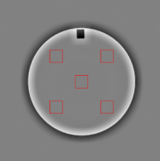

Fig. 1 *Inoise* derived from slice 7 with 5 ROIs indicated

### Geometric Accuracy

On PACS,

1. Measure the distances MagNET-H1, MagNET-H1, MagNET-H1 as indicated on fig.2.
2. Measure the distances MagNET-V1, MagNET-V1, MagNET-V1 as indicated on fig.2.

Fig.2 Geometric Accuracy measurement

### Uniformity

The following is steps are taken from the test guidance for the ACR phantom [3]. On MicroDICOM,

* Display slice location 7.
* Place a large, circular (ROI) of size 160cm2 in the center of the phantom. This is the region where the uniformity is measured.
* Set the window width to 1 and lower the level till the large ROI is white
* Slowly increase the level until an area of 1cm2 of dark pixels appears.
* Measure the mean pixel value in this area (1cm2 circular ROI), this is the low signal value.
* Increase the window level until a region 1cm2 of white pixels remain.
* Once again measure the mean pixel value in this region (1cm2 circular ROI), this is the high signal value.
* Calculate the uniformity as:

$$PIU=100\left(1- \frac{high-low}{high+low}\right)$$

For more details please see [3].

### Ghosting

On MicroDICOM,

1. Draw 5 ROIs on slice 7 as indicated in fig.3

$Ghost ratio(\%)=100×\frac{\left(top+bottom\right)-(left+right)}{2×large}$

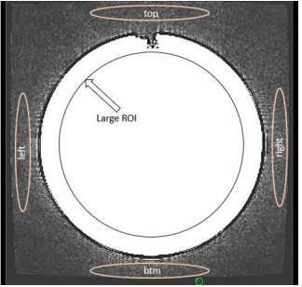

Fig.3 Ghosting

### Slice Position

On microDICOM,

1. On slice 1 magnify and adjust windowing to a narrow window such that the cross-bar object is visualized as shown in fig.4. Measure distance indicated. *nb.* direction of misalignment is determined by the relative positions of the right & left cross-bars, thus: left bar lower than right bar= negative (inferior) misalignment; left bar higher than right bar = positive (superior) misalignment
2. Repeat step 1 on slice 11.

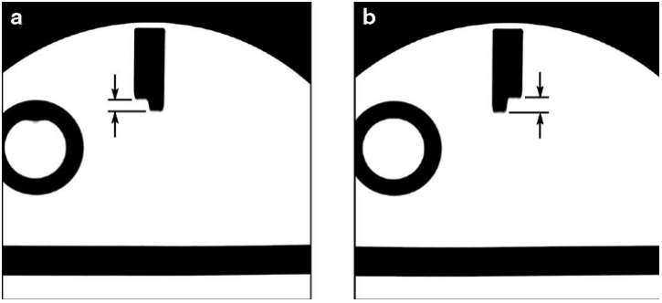

Fig.4. Slice Position Accuracy

### Slice Width

On imageJ,

1. On slice 1 adjust to a narrow window until ramps can be visualized.
2. Draw a 3-pixel wide rectangle on the lower ramp (LH fig.5), draw its profile (*Anaylse>Plot profile)* and copy the raw data via *List* on the profile viewer (RH fig.5).

In Excel

1. Paste the profile into Excel.
2. Calculate *Imax* as the mean of 10 values around the absolute maximum pixel (±5 pixels).
3. Locate the nearest neighbours *x1* and *x2* of the *Imax*/2 value on the low-side of the profile and linearly interpolate to determine the exact position x’1.
4. Repeat step 5 for the high-side of the profile to determine x’2
5. Repeat steps 2-7 for the upper ramp
6. Slice thickness is computed as follows:

$$Slice Thickness=0.2 \frac{FWHM_{top }× FWHM_{Bottom}}{FWHM_{top}+ FWHM_{Bottom}}$$

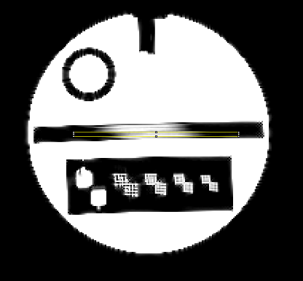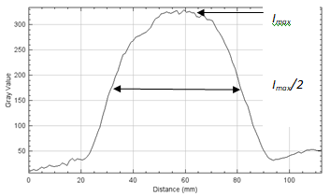

Fig.5 Slice-Width

### Manual Spatial Resolution

In ImageJ,

* Open slice 1 and zoom into the 1.1mm resolution grid.
* Previously the peaks and troughs for both the horizontal and vertical components of the grid have been selected (within the GUI).
* Reproduce the location of these points in ImageJ using the multi-point tool.
* Determine the pixel value at each of these points.
  + This will require linear interpolation of the points.
  + Practically this was done by extracting the location of the points and interpolating it within an independent python script.
* Compute the mean peak and mean trough for the horizontal and vertical component.
* The contrast response is found with the following function:
$$Contrast Response_{Horizontal}=\frac{Mean Peak_{Horizontal}-Mean Trough_{Horizontal}}{Mean Peak_{Horizontal}}$$

$$Contrast Response_{Vertical}=\frac{Mean Peak_{Vertical}-Mean Trough_{Vertical}}{Mean Peak_{Vertical}}$$

* Repeat the above for each other resolution block.

### Automatic Spatial Resolution

In ImageJ,

* Open slice 1 and zoom into 1.1mm resolution grid.
* Using the line tool, draw a straight line covering the same location as was sampled via the script. Do this for both the horizontal and vertical components.
* Plot the sampled line using the Analyze->Plot Profile. Do this for both the horizontal and vertical components
* Record the y-value of the most prominent 4 peaks and most prominent 3 troughs on both the horizontal and vertical components.
* Computer the mean peak and mean trough for the horizontal and vertical lines.
* Compute the contrast response as below:
$$Contrast Response_{Horizontal}=\frac{Mean Peak_{Horizontal}-Mean Trough_{Horizontal}}{Mean Peak_{Horizontal}}$$

$$Contrast Response_{Vertical}=\frac{Mean Peak_{Vertical}-Mean Trough_{Vertical}}{Mean Peak_{Vertical}}$$

* Repeat the above for each other resolution block.

## Test Tolerances

The comparable data are manual measurements of the test parameters. The dominant source of error in the comparable data therefore is operator positioning & sizing of ROIs which will cause variation in ROI statistics with a normal distribution. The tolerance must eliminate all failures due to erroneous comparable data whilst maintaining a high sensitivity for errors in the code. The proposed values in table 1 are based on 3 stanadrd deviations (eliminating 99.7% of manual measurement errors). The manual measurement replicates as closely as possible Scottish-Hazen’s algorithm. This manual measurment is repeated and the standard deviation of the results found. The tolerance is then computed as 3 times this value.

The proposed tolerances are generally small in comparison with the phantom manufacturer’s recommended tolerances for in-service use (shown in table 1); reflecting a higher expectation at validation to ensure that the software provides accurate in-service results that will sensitively detect scanner data that is out-of-manufacturer’s tolerance.

|  |  |  |
| --- | --- | --- |
| **Module** | **Tolerance** | **Manufacturer’s Tolerances** |
| SNR | ±3.0% | ±10% |
| Uniformity | ±2% | >90% (1.5T)  >85%(3.0T) |
| Distortion | ±0.6mm | <2mm(ACR) or <1.0% for CoV(MagNET) |
| Slice Width | ±0.6mm | ±1.0mm |
| Slice Position | ±0.6mm | <7mm |
| Spatial Resolution | ±8% | None Given |
| Ghosting | 0.5% | <3.0% |

Table 1. Tolerances for checking accuracy of measurement.

# References

1. Specification for MRI QA software “Scottish-Hazen”, NHS Highland
2. Software Description for “Scottish-Hazen”, ???
3. Large and Medium Phantom Test Guidance for the MRI Accreditation Program, American College of Radiology 2022
4. MagNET Test Objects Instructions for Use, v.4 2006